Machine Description | A deliberately vulnerable lab machine for practicing web app exploits, privilege escalation, and post-exploitation to gain user and root access.
Target IP | 192.168.0.131
Vulnerability Name | • Wordpress Weak Credentials & Privilege Escalation  • Credential Brute Force and Privilege Escalation  • Insecure WordPress Login and Git Access Misconfiguration
Port / Service | 80/http, ssh/7744
Severity | 8.1 high
Attack Vetor | CVSS:3.0/AV:L/AC:H/PR:N/UI:N/S:C/C:H/I:H/A:H
Proof of Concept (PoC) | STEP 1 – Nmap to find the IP of the target machine.  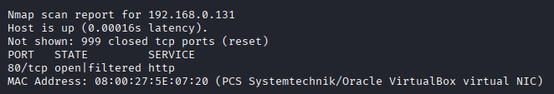  STEP 2 – Nmap Scan to discover open ports and Services  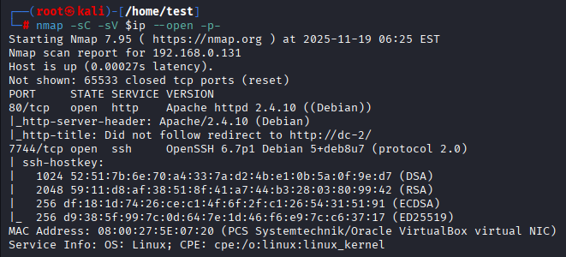  # nmap –p- -sC –sV $ip –open  Step 3- By using wpscan we found 3 valid users  # wpscan –url $url –disable-tls-checks –enumerate p –enumerate t –enumerate u  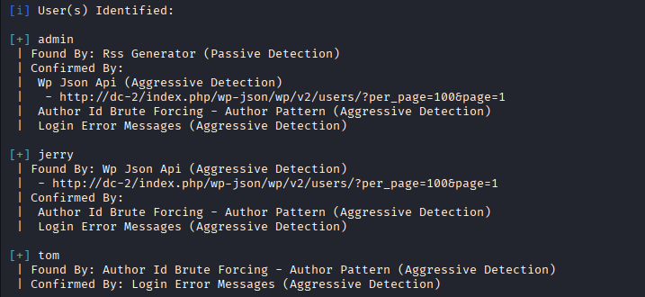  Step 4 – We created a custom Word list using the words in the website  Step 5 – We found valid creds using brute force  # wpscan –url $url –disable-tls-checks –U users –P ./cewl.txt  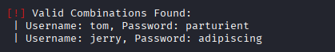  Step 6 – We got in as valid user.  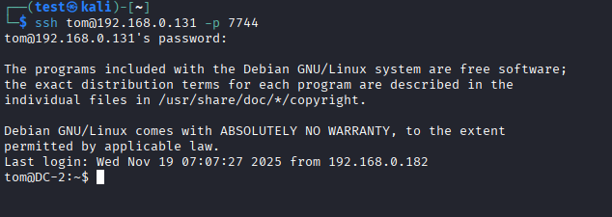  Step 7 – We did lateral movement to user ‘jerry’ and found the git has no password.  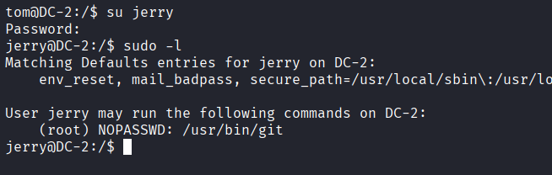  Step 8 – we can use this to escalate your privileges through ‘Pagination’ ,we increased the font size to overflow the page and run this command.  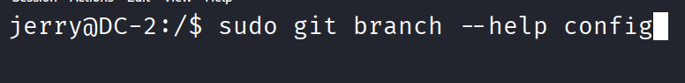  Step 9 - Type “\!/bin/bash” and BOOM we have root!!  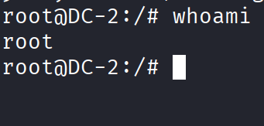  PROOF:  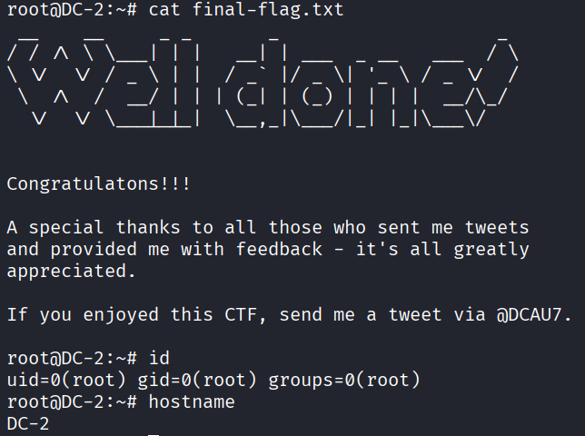
Remediation | • Use strong, unique passwords for all WordPress accounts and enforce password policies.  • Disable or restrict the Git service so it cannot be accessed without a password.  • Keep WordPress, plugins, and themes updated to avoid known security issues.  • Limit user permissions so normal users cannot perform actions that could lead to system-level access.  • Enable multi-factor authentication (MFA) for WordPress logins.  • Regularly audit users, plugins, and system services for misconfigurations.
Impact | • Attackers can log in as valid WordPress users using brute-forced weak passwords.  • Lateral movement allows attackers to access additional accounts (e.g., jerry).  • Misconfigured Git access can allow attackers to reach sensitive internal functionality.  • Privilege-escalation flaw (pagination misuse) enables attackers to run system commands and gain root access.  • Full system compromise could lead to:  - Loss of data  - Website defacement  - Unauthorized control of the server  - Use of the server for further attacks
References | WordPress Password Security  https://wordpress.org/support/article/password-best-practices/  Understanding Brute Force Attacks  https://www.kaspersky.com/resource-center/definitions/brute-force-attack  Principle of Least Privilege (simple explanation)  https://www.techtarget.com/searchsecurity/definition/principle-of-least-privilege-POLP  What is Privilege Escalation?  https://www.crowdstrike.com/en-us/cybersecurity-101/cyberattacks/privilege-escalation/

